Practical - 4
Practical Title: JavaScript DOM Manipulation, Event Handling, and UI Interactivity

Problem Definition: Add dynamic UI components such as collapsible FAQ, modal popup, image/content slider, notification banner, hamburger menu, and light/dark theme switcher using JavaScript.

Theory

How are DOM elements selected and modified?
Answer: DOM elements are selected using methods like getElementById() and querySelector(), and modified using properties like textContent, style, and classList

Are event listeners attached correctly?
Answer: Yes, event listeners are attached correctly using addEventListener() to handle user actions like clicks.

3. Is localStorage used for remembering theme choice?
Answer: Yes, localStorage stores the user's theme choice so it remains the same even after refreshing the page.

4.Does interactivity improve usability without breaking accessibility?
Answer: Yes, interactivity makes the website easier to use while keeping buttons, navigation, and content accessible.

Implementation
FAQ: Questions can be expanded and collapsed by clicking on them.
Modal Popup: A popup window appears when the user clicks the required button and can be closed using the close button.
Slider: Users can change between different content using navigation controls.
Notification Banner: A notification message is displayed and can be closed by the user.
Hamburger Menu: The navigation menu opens and closes when the hamburger icon is clicked.
Light/Dark Theme: JavaScript changes the theme and uses localStorage to remember the user's selected theme after refreshing the page.

Evidence of Work (Screenshots)
Figure 1.1 Notification and slider
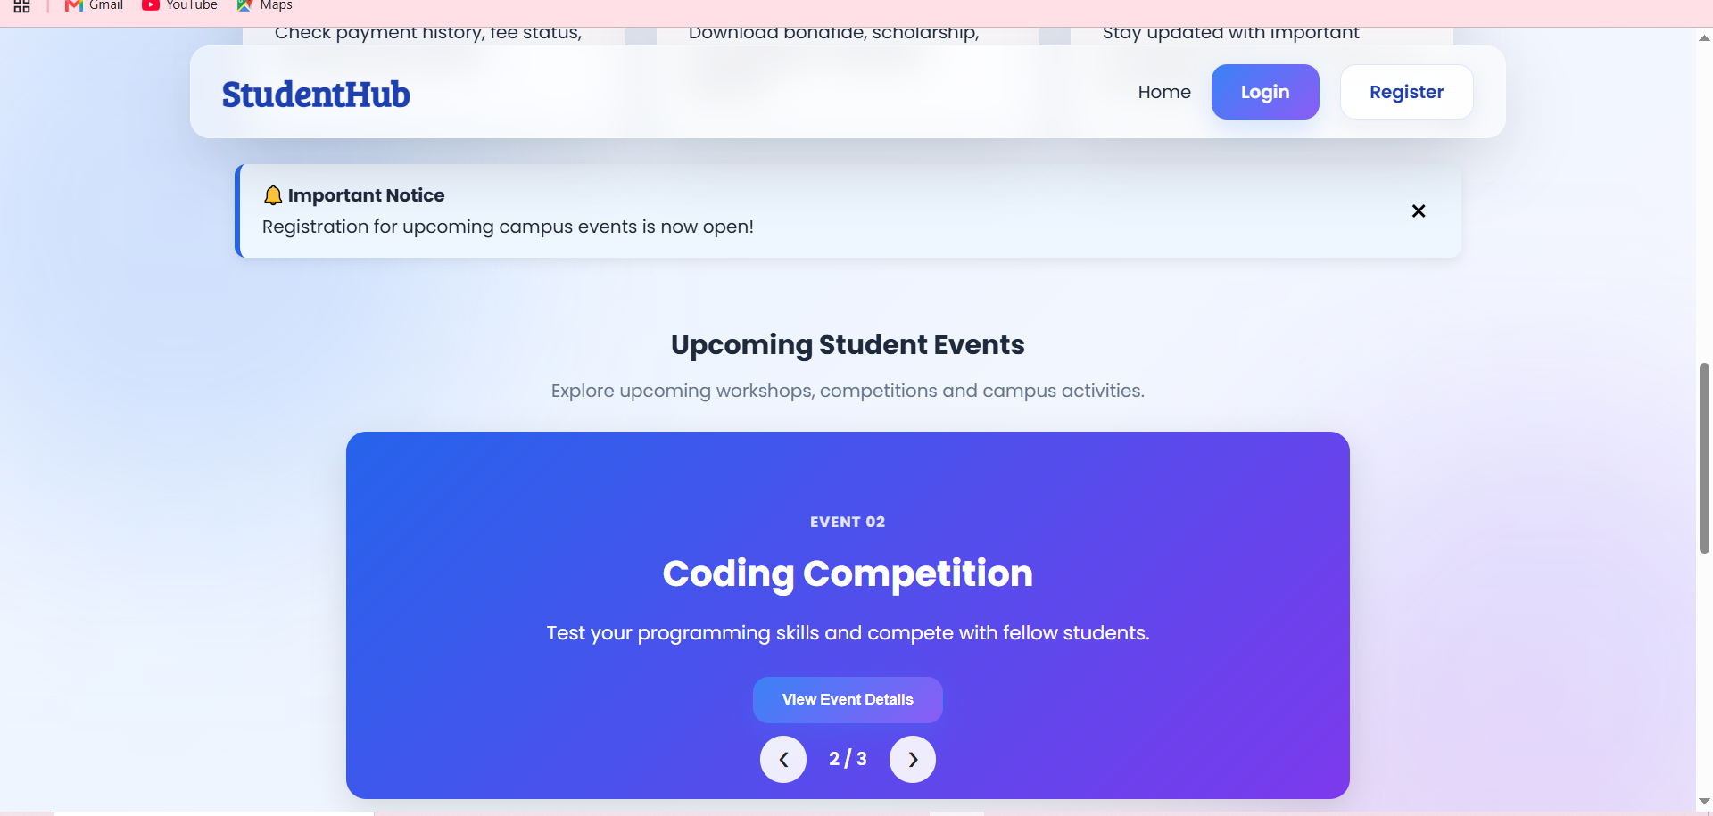
Description: Users can change between different content and remove appeared notification
Figure 1.2 FAQ
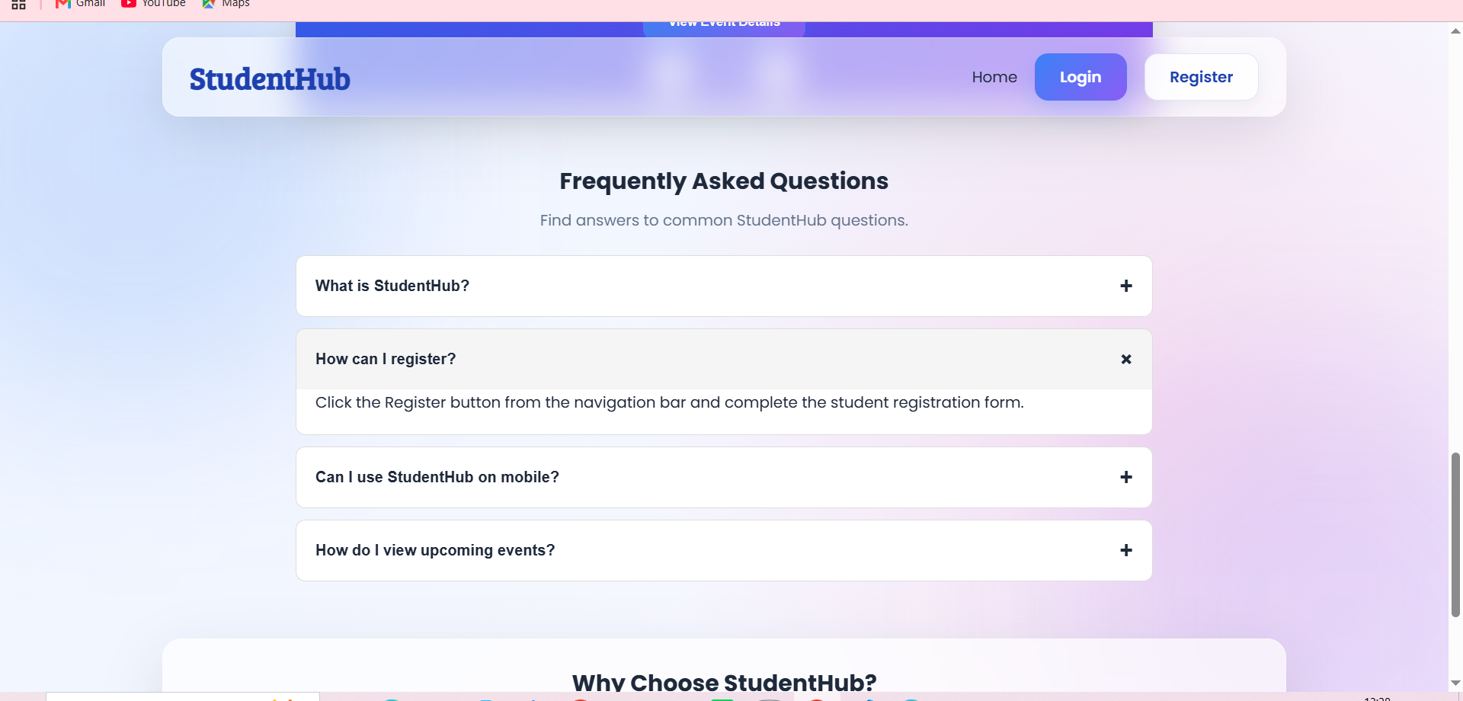
Description: users can click on questions and related answers will be shown.
Figure 1.3 Modal pop up
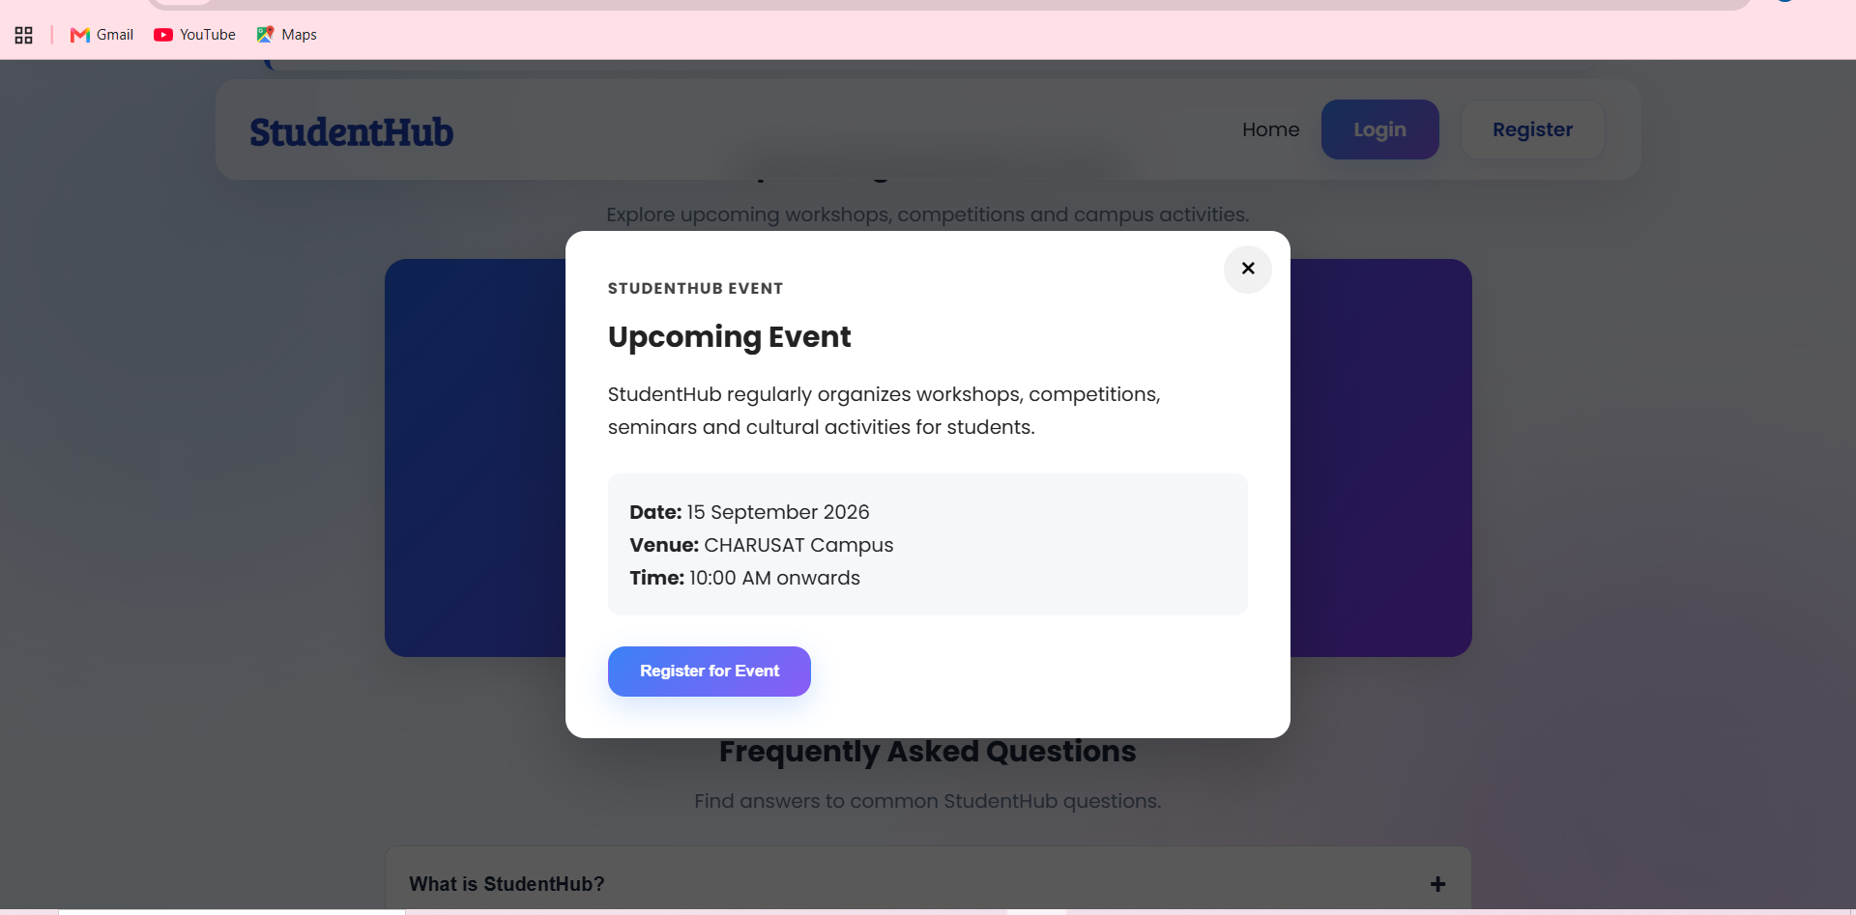
Description: Notification banner is displayed when user clicks on button and can be closed by clicking on cross.
Figure 1.4 Slidebar
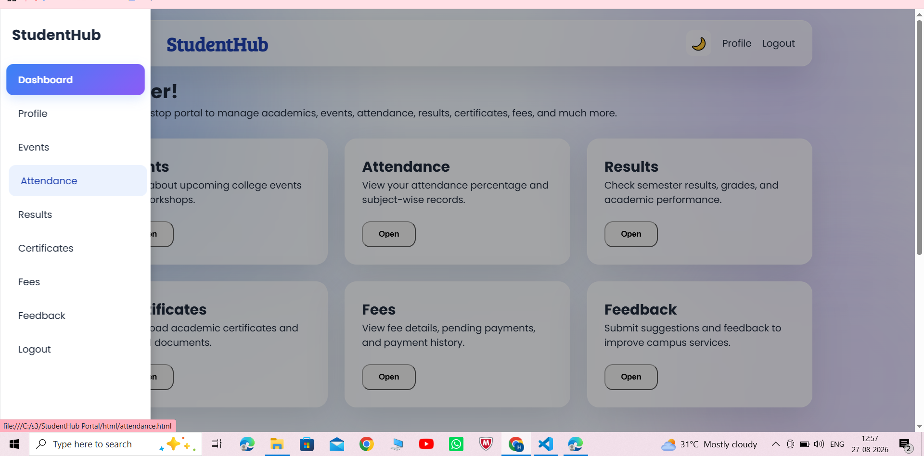
Description: Slidebar when clicked on menu button. It stays open even when the page is changed. After clicking on the outside part of the slidebar, it closes.

Figure 1.5 Light/Dark theme
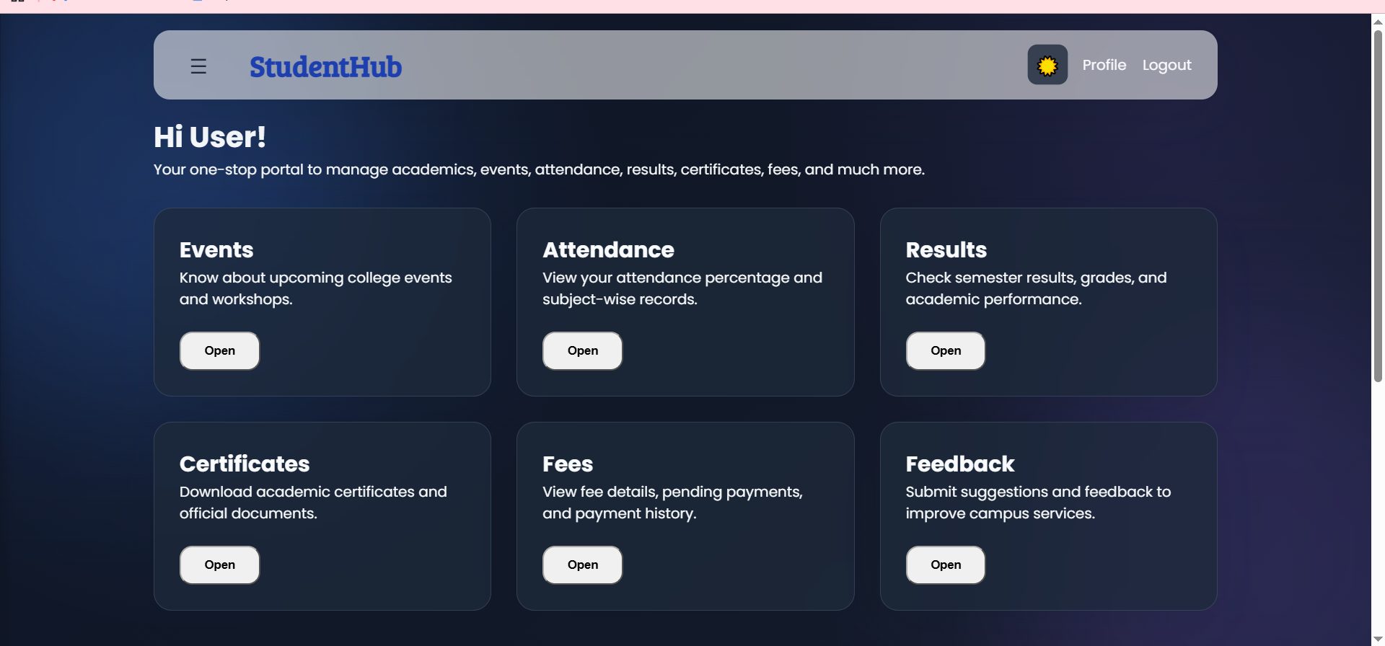
Description: Dark theme is applied on the website pages when the user clicks on the button .

GitHub Repository Link:

https://github.com/heerce27/StudentHub-Portal.git

Challenges Faced:

Faced challenges like:
- Slidebar application on every page was difficult as I wanted it to stay open even after changing the page.
- Remembering the user's choice of dark theme and storing it in local storage.
- Applying sliding content on the index page and maintaining the measurements.
- Making sure all interactive components worked properly without affecting the overall webpage design.

Learning Outcomes:

Learned how to use DOM manipulation to dynamically change webpage elements.

Learned how to handle user actions using event listeners.

Learned to create interactive components like FAQ, modal popup, slider, notification banner, and hamburger menu.

Learned how to use localStorage to remember the user's theme preference.

Learned how to combine HTML, CSS, and JavaScript to create a more interactive and user-friendly webpage.

Improved my understanding of responsive design and maintaining proper layout measurements.

Faculty Remarks:

